To the Romanian Government
Prime Minister, Ilie Bolojan
Chancellery, Mihai Jurca
Minister of Culture, Demeter András István
Minister of Development, Public Works and Administration, Cseke Attila
Minister of European Funds and Investments, Dragoș-Nicolae Pîslaru

Brussels, 13 March 2026

Re: Support for Timbrul de Arhitectură/The National Architecture Stamp

Dear Madam,
Dear Sirs,

On behalf of the Architects’ Council of Europe (ACE), representing over 600,000 architects across Europe, I want to express the strong support of the architectural community for Timbrul de Arhitectură/The National Architecture Stamp, administered by the Order of Architects of Romania (OAR).
Timbrul de Arhitectură resonates profoundly with the ambitions promoted by the ACE and the values shared by the architectural profession across Europe. It also aligns with multiple policies and funding programmes of the European Union that aim to promote a shared culture of architecture in Europe and support the value created by cultural and creative sectors, like the New European Bauhaus initiative, the Creative Europe programme, and the recently adopted Culture Compass for Europe, to name but a few.
Because of these shared ambitions and goals, allow me to express myself favourably for the Timbrul de Arhitectura programme. It is a powerful example of how architecture can serve the public interest by fostering inclusivity, sustainability, and cultural resilience. Through its innovative projects, such as De-a Arhitectura, which educates children about architecture, and Street Delivery, which transforms urban spaces into hubs of civic engagement, Timbrul de Arhitectură demonstrates the profound impact that architecture can have on society. It empowers communities, nurtures creativity, and strengthens the bond between people and their built environment, making it a vital tool for social cohesion and democratic participation.
These collective efforts—by the European Union, the Romanian State, and the architectural profession through the ACE and OAR—are key to reinforcing the importance of cultural and creative sectors in building a cohesive and innovative Europe.
That is why we strongly believe that the Romanian State should continue to champion and support the activity and independence of Timbrul de Arhitectură/The Architecture Stamp, ensuring its ongoing contribution to Romanian society and the broader European architectural community.
Yours sincerely,
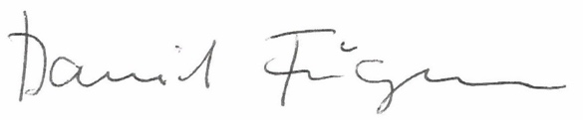

Daniel FÜGENSCHUH
President
Architects’ Council of Europe

